|  |  |  |  |
| --- | --- | --- | --- |
| **Name of Student: NINAD AVINASH PATIL** | | | |
| **Roll No: 33** | | **Lab Practical Number: 6(B)** | |
| **Title of Lab Practical: WCF**  **Design an Application to fetch data from the EMP table. Test the service and design a Web client to consume this service.** | | | |
| **DOP: 23/04/2021** | | **DOS: 30/04/2021** | |
| **CO Mapped: CO1** | **PO Mapped: PO3, PO5, PO7,**  **PO12, PSO1, PSO2** | **Faculty Signature:** | **Marks:** |

**Practical No 6(B)**

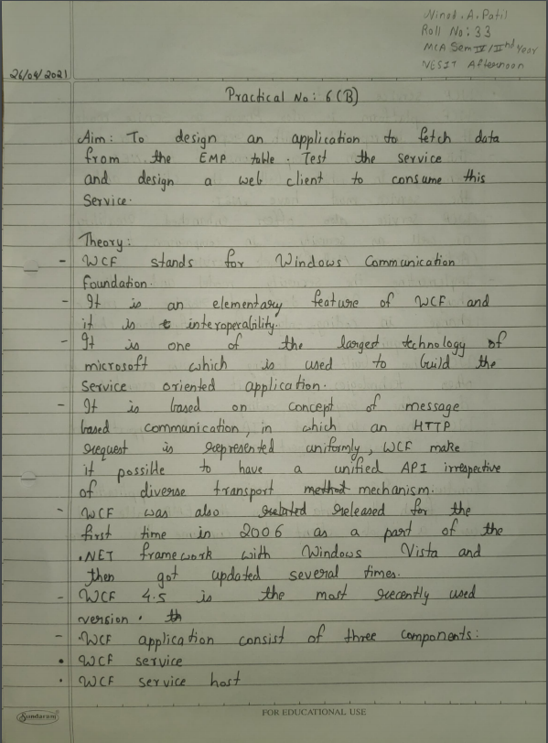

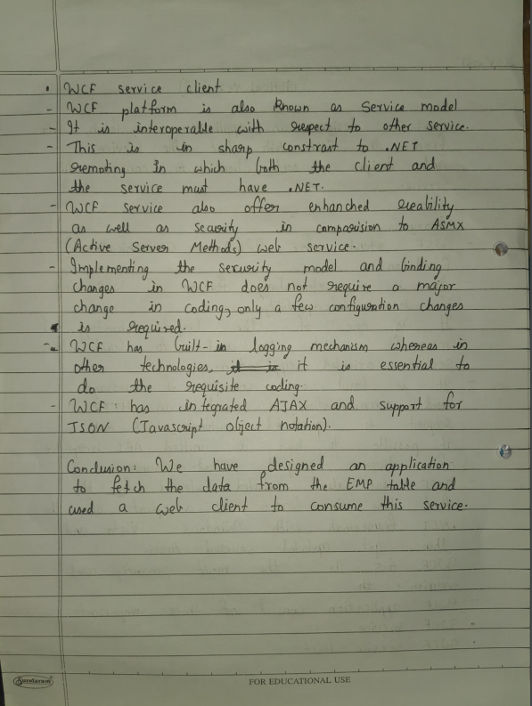

**Code:**

**Service1.svc**

using System;

using System.Collections.Generic;

using System.Linq;

using System.Runtime.Serialization;

using System.ServiceModel;

using System.ServiceModel.Web;

using System.Text;

using System.Data.SqlClient;

using System.Data;

namespace P6B

{

public class Service1 : IService1

{

public FetchData GetData()

{

FetchData data = new FetchData();

SqlConnection con = new SqlConnection(@"Data Source=NINAD\SQLEXPRESS;Initial Catalog=student;Integrated Security=True");

con.Open();

SqlCommand cmd = new SqlCommand("Select * from EMP", con);

SqlDataAdapter da = new SqlDataAdapter(cmd);

DataTable dt = new DataTable("mytab");

da.Fill(dt);

data.table = dt;

return data;

} } }

**IService1.cs**

using System;

using System.Collections.Generic;

using System.Linq;

using System.Runtime.Serialization;

using System.ServiceModel;

using System.ServiceModel.Web;

using System.Text;

using System.Data;

namespace P6B

{

[ServiceContract]

public interface IService1

{

[OperationContract]

FetchData GetData();

}

[DataContract]

public class FetchData

{

[DataMember]

public DataTable table

{

get;

set;

}

}

}

**WebForm1.aspx**

<%@ Page Language="C#" AutoEventWireup="true" CodeBehind="WebForm1.aspx.cs" Inherits="P6B.WebForm1" %>

<!DOCTYPE html PUBLIC "-//W3C//DTD XHTML 1.0 Transitional//EN" "http://www.w3.org/TR/xhtml1/DTD/xhtml1-transitional.dtd">

<html xmlns="http://www.w3.org/1999/xhtml">

<head id="Head1" runat="server">

<title>Employee Details</title>

</head>

<body><h3>WCF Employee Details</h3>

<form id="form1" runat="server">

<div>

<asp:Button ID="Button1" runat="server" Text="Button" onclick="Button1_Click" />

<br />

<br />

<asp:GridView ID="GridView1" runat="server">

</asp:GridView>

</div>

</form>

</body>

</html>

**WebForm1.aspx.cs**

using System;

using System.Collections.Generic;

using System.Linq;

using System.Web;

using System.Web.UI;

using System.Web.UI.WebControls;

using System.Collections;

using P6B.ServiceReference1;

using System.Data;

namespace P6B

{

public partial class WebForm1 : System.Web.UI.Page

{

protected void Page_Load(object sender, EventArgs e)

{

}

ServiceReference1.Service1Client client = new ServiceReference1.Service1Client();

protected void Button1_Click(object sender, EventArgs e)

{

ServiceReference1.FetchData data = new ServiceReference1.FetchData();

data = client.GetData();

DataTable dt = new DataTable();

dt = data.table;

GridView1.DataSource = dt;

GridView1.DataBind();

}

}

}

**Output:**

**Service1.svc**

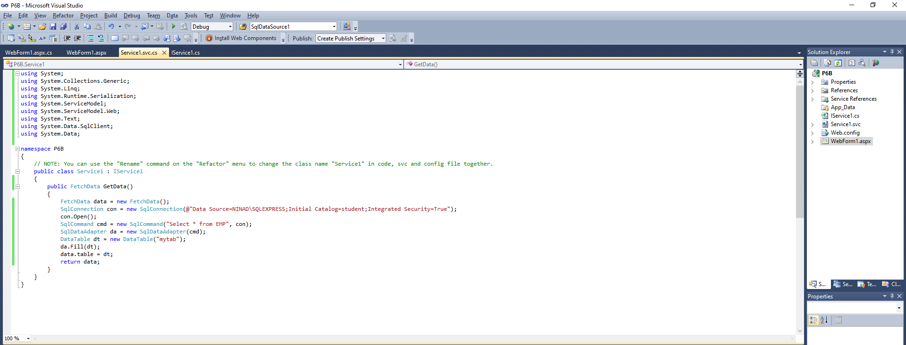

**WebForm1.aspx.cs**

